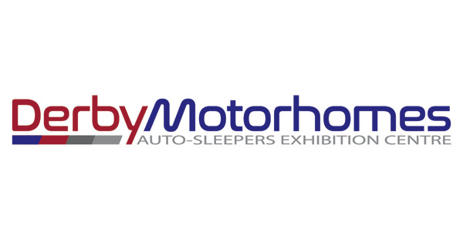

Awaiting Preparation

New Arrival

Please note that this motorhome hasn’t been through our valeting department yet and we apologise for it not being presented to you to our usual high standards.